What´s the Weather Like?

**1. What is the weather like?**

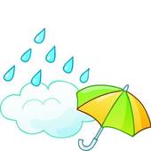



|  |  |  |  |
| --- | --- | --- | --- |
|  |  |  |  |
| It's windy  It's raining  It's sunny It's snowing | It's windy  It's raining  It's sunny It's snowing | It's windy  It's raining  http://www.fotosearch.com/bthumb/UNC/UNC265/u19002365.jpgIt's sunny It's snowing | It's windy  It's raining  It's sunny It's snowing |

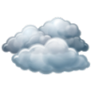

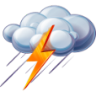



|  |  |  |  |
| --- | --- | --- | --- |
| It's sunny  It's stormy  It's raining  It's snowing | Overcast-icon.pngIt's sunny  It's cloudy  It's lightning  It's snowing | It's sunny  It's windy  It's a rainbow  It's snowing | It's hot  It's windy  It's raining  It's snowing |

**2. Complete the sentences:**



** It is I need my .**

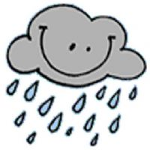

**It is I need my .**



**It is I need my .**



**It is I need my .**

|  |  |  |  |
| --- | --- | --- | --- |
|  |  |  |  |

**3. Look at the map and describe the weather in each city*:***

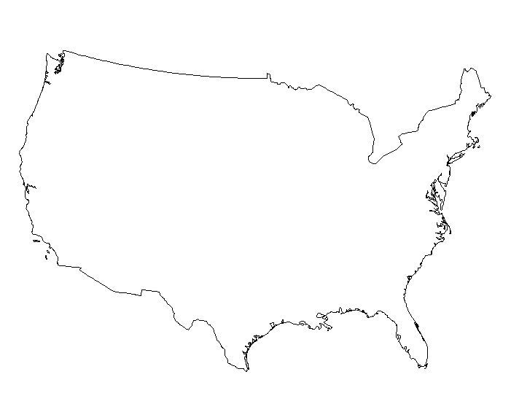

**nubes**

**cold weather icon**

**Seattle**

**Chicago**

**NUVCHUVNUVCHUV**

**Boston**

**nubes**

**Denver**

**Sacramento**

**nubesNUVCHUV**

**Atlanta**

**Las Vegas**



**NUVCHUV**

**Dallas**

**Miami**

1. **The weather in *Miami* is .**
2. **The weather in *Denver* is .**
3. **The weather in *Chicago* is .**
4. **The weather in *Las Vegas* is .**
5. **The weather in *Dallas* is .**
6. **The weather in *Sacramento* is .**
7. **The weather in *Atlanta* is .**
8. **The weather in *Seattle* is .**
9. **The weather in *Boston* is .**

